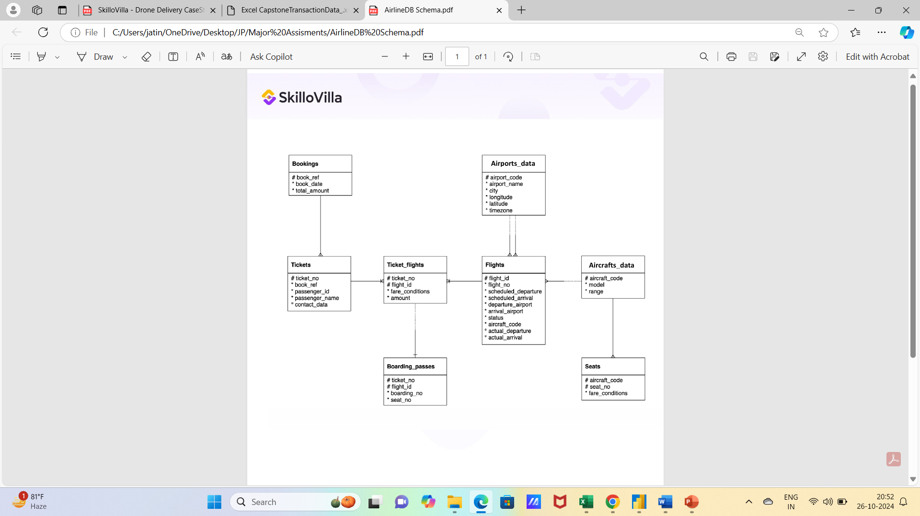

**Attempt the following Questions-**

1. ***Represent the “book_date” column in “yyyy-mmm-dd” format using Bookings table***

*Expected output: book_ref, book_date (in “yyyy-mmm-dd” format) , total amount*

**Answer:**

SELECT

    book_ref,

    TO_CHAR(book_date, 'YYYY-Mon-DD') AS book_date,

    total_amount

FROM

    Bookings

1. **Get the following columns in the exact same sequence.**

Expected columns in the output: ticket_no, boarding_no, seat_number, passenger_id, passenger_name.

**Answer:**

select

    t.ticket_no,

    boarding_no,

    seat_no,

    passenger_id,

    passenger_name

from TICKETS t

inner join BOARDING_PASSES bp

on t.ticket_no = bp.ticket_no

1. **Write a query to find the seat number which is least allocated among all the seats?**

**Answer:**

with t1 as

(select

    seat_no,

    count(ticket_no) allocation_count

from BOARDING_PASSES

group by 1)

select

    seat_no,

    allocation_count

from t1

where allocation_count = (select

min(allocation_count) as allocation_count

from t1)

1. ***In the database, identify the month wise highest paying passenger name and passenger id.***

Expected output: Month_name(“mmm-yy” format), passenger_id, passenger_name and total amount

**Answer:**

with t1 as

(select

    to_char(book_date, 'mon-yy') month_name,

    passenger_id,

    passenger_name,

    total_amount,

    rank() over(partition by  to_char(book_date, 'mon-yy') order by total_amount desc)  as rank

from bookings b

inner join tickets t

on b.book_ref = t.book_ref

group by 1,2,3,4)

select

    month_name,

    passenger_id,

    passenger_name,

    total_amount

from t1

where rank = 1

1. ***In the database, identify the month wise least paying passenger name and passenger id?***

Expected output: Month_name(“mmm-yy” format), passenger_id, passenger_name and total amount

**Answer:**

with t1 as

(select

    to_char(book_date, 'mon-yy') month_name,

    passenger_id,

    passenger_name,

    total_amount,

    rank() over(partition by  to_char(book_date, 'mon-yy') order by total_amount asc)  as rank

from bookings b

inner join tickets t

on b.book_ref = t.book_ref

group by 1,2,3,4)

select

    month_name,

    passenger_id,

    passenger_name,

    total_amount

from t1

where rank = 1

1. **Identify the travel details of non stop journeys or return journeys (having more than 1 flight).**

Expected Output: Passenger_id, passenger_name, ticket_number and flight count.

**Answer:**

s select

    t.passenger_id,

    t.passenger_name,

    t.ticket_no,

    count(f.flight_id) as flight_count

from TICKETS t

inner join TICKET_FLIGHTS tf

on t.ticket_no = tf.ticket_no

inner join FLIGHTS f

on tf.flight_id = f.flight_id

group by 1,2,3

having count(f.flight_id) > 1

1. **How many tickets are there without boarding passes?**

Expected Output: just one number is required.

**Answer:**

SELECT COUNT(t.ticket_no) AS tickets_without_boarding_pass

FROM Tickets t

LEFT JOIN Boarding_Passes bp ON t.ticket_no = bp.ticket_no

where bp.ticket_no is null

1. **Identify details of the longest flight (using flights table)?**

Expected Output: Flight number, departure airport, arrival airport, aircraft code and durations.

**Answer:**

with duration_table as

(select

    flight_no,

    departure_airport,

    arrival_airport,

    aircraft_code,

    actual_arrival-actual_departure as duration,

    rank() over(order by actual_arrival-actual_departure desc) as duration_rank

from flights

where actual_arrival-actual_departure is not null)

select

    flight_no,

    departure_airport,

    arrival_airport,

    aircraft_code,

    duration

from duration_table

where duration_rank = 1

1. **Identify details of all the morning flights (morning means between 6AM to 11 AM, using flights table)?**

Expected output: flight_id, flight_number, scheduled_departure, scheduled_arrival and timings.

**Answer:**

select

    flight_id,

    flight_no,

    scheduled_departure,

    scheduled_arrival,

    to_char(scheduled_departure,'HH24')||':'||to_char(scheduled_departure,'MI')||':'||to_char(scheduled_departure,'SS') as Timings

from flights

where to_char(scheduled_departure,'HH24')||':'||to_char(scheduled_departure,'MI')||':'||to_char(scheduled_departure,'SS')

between '06:00:00' and '11:00:00'

1. **Identify the earliest morning flight available from every airport.**

Expected output: flight_id, flight_number, scheduled_departure, scheduled_arrival, departure airport and timings.

**Answer:**

Select

    f.flight_id,

    f.flight_no,

    f.scheduled_departure,

    f.departure_airport,

    to_char(f.scheduled_departure,'HH24')||':'||to_char(f.scheduled_departure,'MI')||':'||to_char(f.scheduled_departure,'SS') as Timings

From flights f

Join (

    Select

    departure_airport,

    Min(scheduled_departure) AS min_scheduled_departure

    From flights

    Group by departure_airport) min_flights

on f.departure_airport = min_flights.departure_airport

and f.scheduled_departure = min_flights.min_scheduled_departure

1. **Questions:** **Find list of airport codes in Europe/Moscow timezone**

Expected Output: Airport_code.

**Answer:**

select

    airport_code

from airports

where timezone = 'Europe/Moscow'

1. **Write a query to get the count of seats in various fare condition for every aircraft code?**

Expected Outputs: Aircraft_code, fare_conditions ,seat count

**Answer:**

select

    aircraft_code,

    fare_conditions,

    count(seat_no)

from seats

group by 1,2

order by 1,2

1. **How many aircrafts codes have at least one Business class seats?**

Expected Output : Count of aircraft codes

**Answer:**

with t1 as

(SELECT

    aircraft_code,

    count(fare_conditions)

from SEATS

where fare_conditions = 'Business'

group by 1)

select count (*)

from t1

1. **Find out the name of the airport having maximum number of departure flight**

Expected Output : Airport_name

**Answer:**

with t1 as

(select

    airport_name,

    count(*)

from airports ap

inner join flights fl

on ap.airport_code = fl.departure_airport

group by 1

order by 2 desc

limit 1)

select airport_name

from t1

1. **Find out the name of the airport having least number of scheduled departure flights**

Expected Output : Airport_name

**Answer:**

with t1 as

(select

    airport_name,

    count(scheduled_departure)

from airports ap

inner join flights fl

on ap.airport_code = fl.departure_airport

group by 1

order by 2 asc

limit 1)

select airport_name

from t1

1. **How many flights from ‘DME’ airport don’t have actual departure?**

Expected Output : Flight Count

**Answer:**

select

    count(flight_id)

from flights

where departure_airport = 'DME' and actual_departure is null

1. **Identify flight ids having range between 3000 to 6000**

Expected Output : Flight_Number , aircraft_code, ranges

**Answer:**

select

    flight_no,

    fl.aircraft_code,

    range as ranges

from flights fl

inner join aircrafts af

on fl.aircraft_code = af.aircraft_code

where range between 3000 and 6000

1. **Write a query to get the count of flights flying between URS and KUF?**

Expected Output : Flight_count

**Answer:**

select

    count(flight_id)

from flights

where departure_airport = 'URS' and

arrival_airport = 'KUF'

1. **Write a query to get the count of flights flying from either from NOZ or KRR?**

Expected Output : Flight count

**Answer:**

select

    count(flight_id)

from flights

where departure_airport in ('NOZ', 'KRR')

1. **Write a query to get the count of flights flying from KZN,DME,NBC,NJC,GDX,SGC,VKO,ROV**

Expected Output : Departure airport ,count of flights flying from these airports.

**Answer:**

select

    departure_airport,

        count(flight_id)

from flights

where departure_airport in ('KZN','DME','NBC','NJC','GDX','SGC','VKO','ROV')

group by 1

1. **Write a query to extract flight details having range between 3000 and 6000 and flying from DME**

Expected Output :Flight_no,aircraft_code,range,departure_airport

**Answer:**

select

    flight_no,

    fl.aircraft_code,

    range,

    departure_airport

from flights fl

inner join aircrafts af

on fl.aircraft_code = af.aircraft_code

where range between 3000 and 6000 and departure_airport = 'DME'

1. **Find the list of flight ids which are using aircrafts from “Airbus” company and got cancelled or delayed**

Expected Output : Flight_id,aircraft_model

**Answer:**

 select

    flight_id,

    model

from FLIGHTS f

inner join AIRCRAFTS a

on f.aircraft_code = a.aircraft_code

where status in ('Cancelled','Delayed') and model like '%Airbus%'

1. **Find the list of flight ids which are using aircrafts from “Boeing” company and got cancelled or delayed**

Expected Output : Flight_id,aircraft_model

**Answer:**

 select

    flight_id,

    model

from FLIGHTS f

inner join AIRCRAFTS a

on f.aircraft_code = a.aircraft_code

where status in ('Cancelled','Delayed') and model like '%Boeing%'

1. **Which airport(name) has most cancelled flights (arriving)?**

Expected Output : Airport_name

**Answer:**

 with cancellation_count as

(select

    airport_name,

    count(flight_id),

    rank () over(order by count(flight_id) desc)

from FLIGHTS f

inner join AIRPORTS a

on f.arrival_airport = a.airport_code

where status = 'Cancelled'

group by 1)

select

    airport_name

from cancellation_count

where rank = 1

1. ***Identify flight ids which are using “Airbus aircrafts”***

*Expected Output : Flight_id,aircraft_model*

**Answer:**

select

    flight_id,

    model

from FLIGHTS f

inner join AIRCRAFTS a

on f.aircraft_code = a.aircraft_code

where model like '%Airbus%'

1. ***Identify date-wise last flight id flying from every airport?***

*Expected Output: Flight_id,flight_number,schedule_departure,departure_airport*

**Answer:**

SELECT

    f.flight_id,

    f.flight_no,

    f.scheduled_departure,

    f.departure_airport

FROM flights f

JOIN (

    SELECT

    departure_airport,

    MAX(scheduled_departure) AS max_scheduled_departure

    FROM flights

    GROUP BY departure_airport) max_flights

ON f.departure_airport = max_flights.departure_airport

AND f.scheduled_departure = max_flights.max_scheduled_departure

1. ***Identify list of customers who will get the refund due to cancellation of the flights and how much amount they will get?***

*Expected Output : Passenger_name,total_refund.*

**Answer:**

with booking_details as

(select

    passenger_name,

    f.flight_id,

    total_amount

from tickets t

inner join bookings b

on t.book_ref = b.book_ref

inner join BOARDING_PASSES bp

on t.ticket_no = bp.ticket_no

inner join FLIGHTS f

on bp.flight_id = f.flight_id

order by 1)

select

    passenger_name,

    total_amount as total_refund

from booking_details bd

inner join FLIGHTS f

on bd.flight_id = f.flight_id

where status = 'Cancelled'

1. ***Identify date wise first cancelled flight id flying for every airport?***

*Expected Output : Flight_id,flight_number,schedule_departure,departure_airport*

**Answer:**

SELECT

    f.flight_id,

    f.flight_no,

    f.scheduled_departure,

    f.departure_airport

FROM flights f

JOIN (

    SELECT

    departure_airport,

    min(scheduled_departure) AS min_scheduled_departure

    FROM flights

    where status = 'Cancelled'

    GROUP BY departure_airport) min_flights

ON f.departure_airport = min_flights.departure_airport

AND f.scheduled_departure = min_flights.min_scheduled_departure

1. ***Identify list of Airbus flight ids which got cancelled.***

*Expected Output : Flight_id*

**Answer:**

select

    flight_id

from FLIGHTS f

inner join AIRCRAFTS a

on f.aircraft_code = a.aircraft_code

where status = 'Cancelled' and model like '%Airbus%'

1. ***Identify list of flight ids having highest range.***

*Expected Output : Flight_no, range*

**Answer:**

with t1 as

(select

    flight_no,

    max(range) as range,

    rank() over(order by max(range) desc) range_rank

from FLIGHTS f

inner join AIRCRAFTS a

on f.aircraft_code = a.aircraft_code

group by 1)

select

    flight_no,

    range

from t1

where range_rank = 1